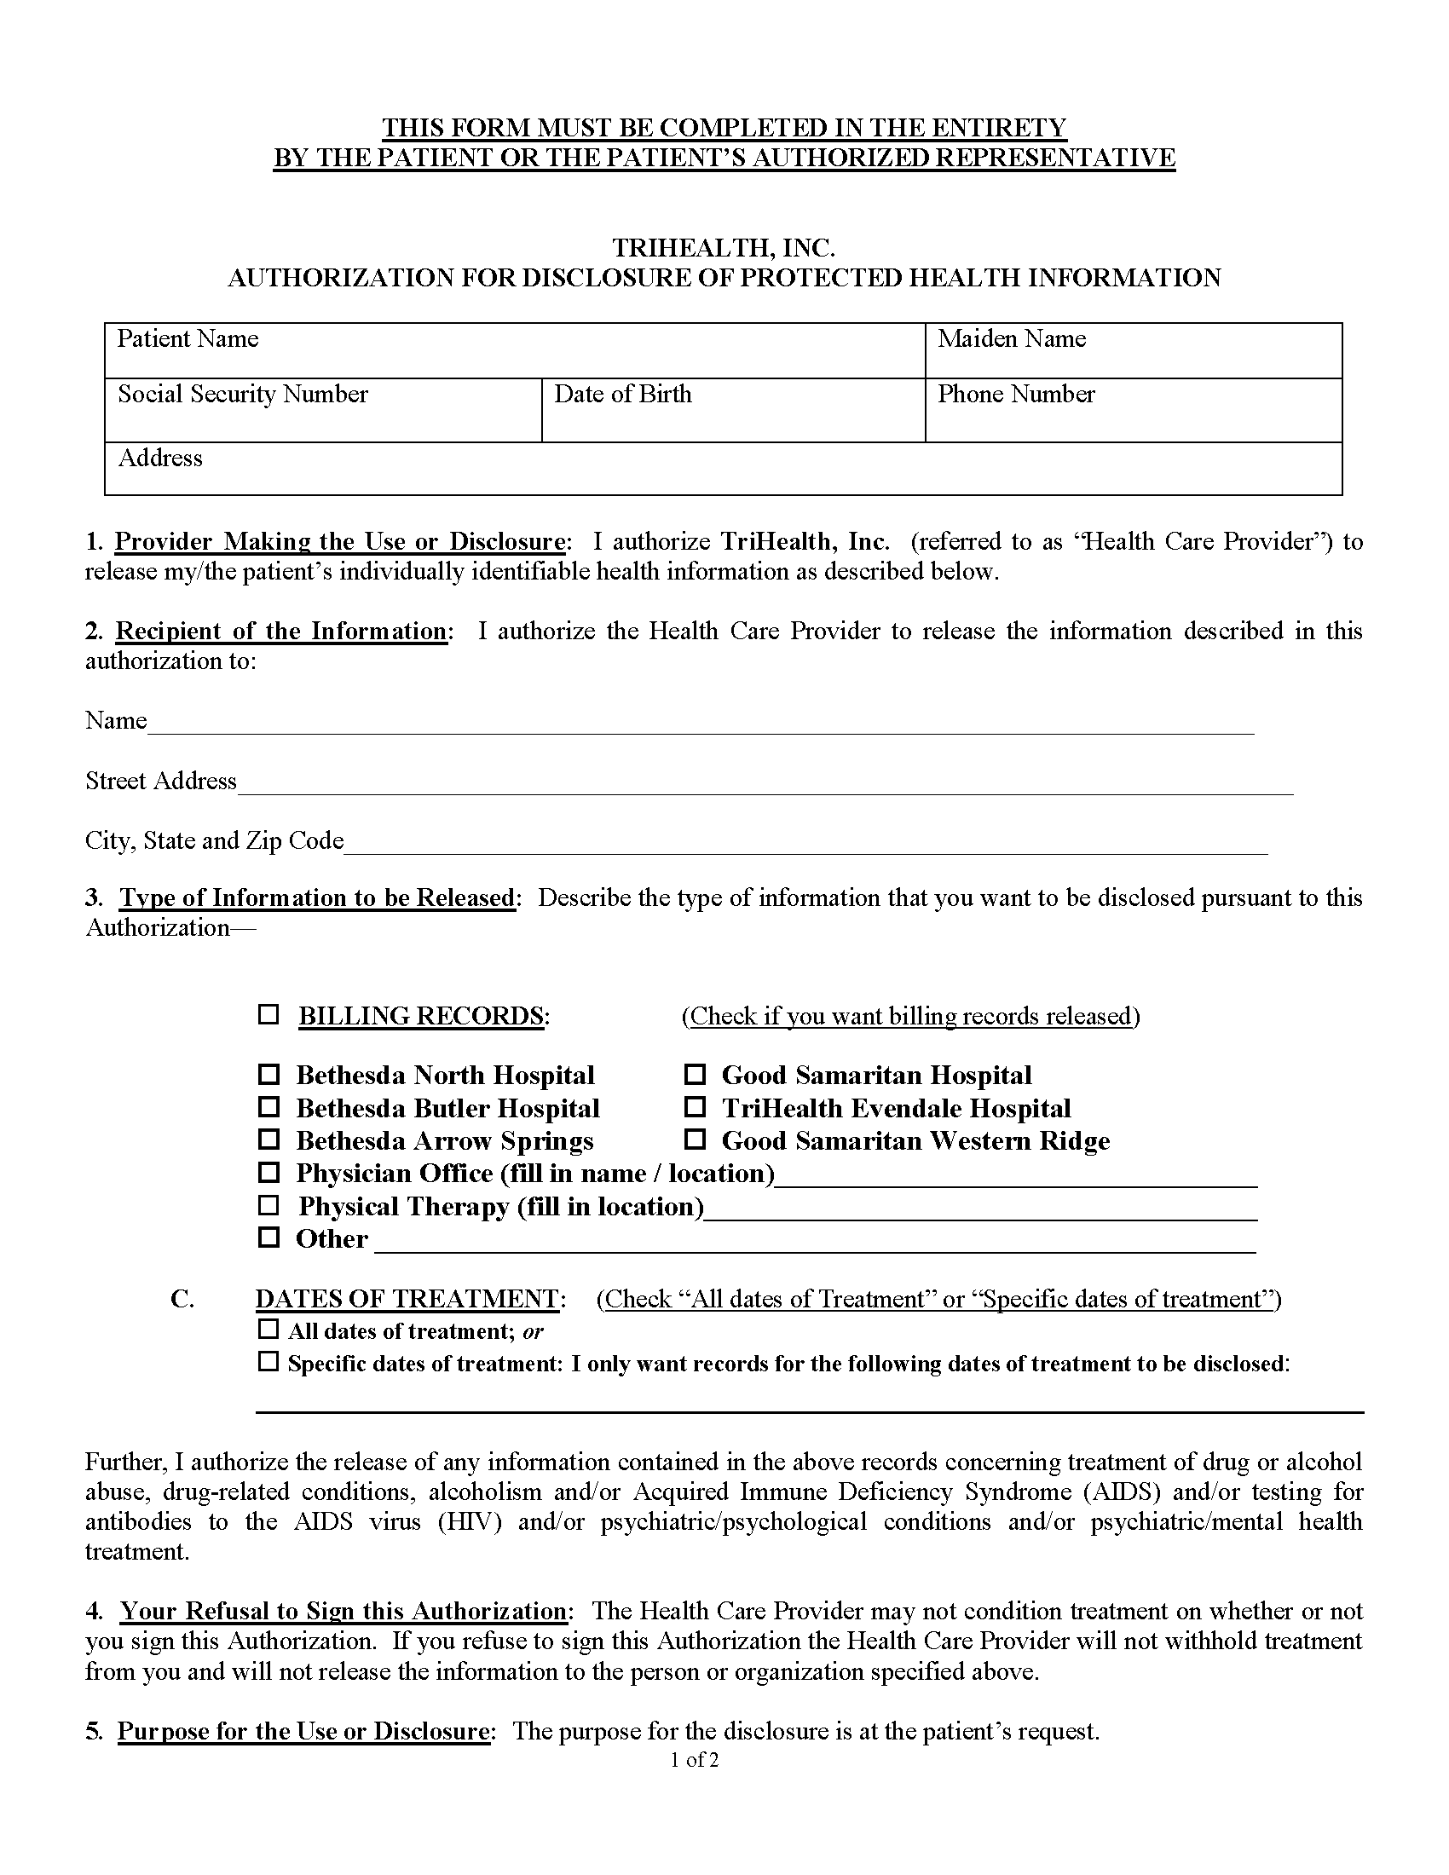
Batman
xxx-xx-5555
01/01/1979

Secret Location Under Office Building Gotham, NJ
Axiom Requisition Copy Service
2869 Jolly Road
Okemos, MI 48864
X
Order Number: 01-29018-001
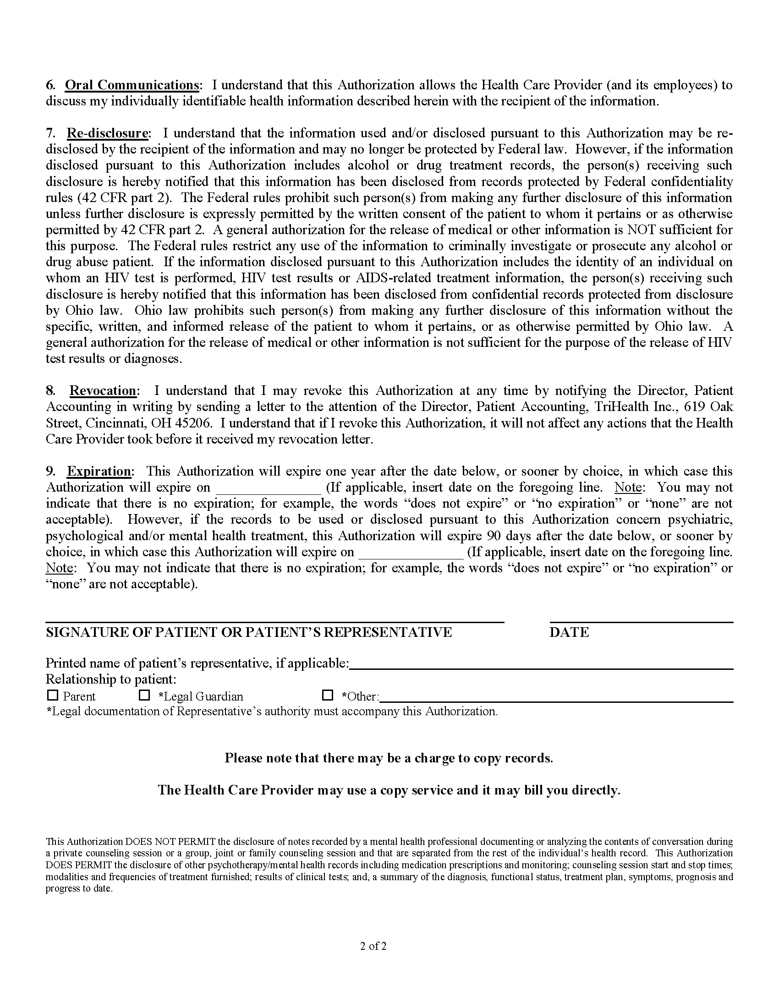
Order Number: 01-29018-001

